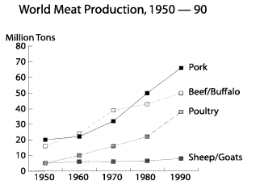
World production increased in all types of meat production sheep and goats betuteen 1950 and 1990. There was a slow rise in the production of pork and beef/buffalo meat up to 1980,the ten year after this pork production increased more rapidly. Poultry production showed a rise trend. Starting fom a low base of just 5 million tons, it increased relatiuely slowly for the first 20 years of the reported period. The poultry production after that it increased sharply, until by 1990 it had reached ouer 30 million tons. From 1950 to 1990 , the production of sheep and goat meat remained steady throughout the period at around 5 million tons.
